Widget Modular

Widget Link

Widget header

Widget Button

Widget home

Widget Kontak

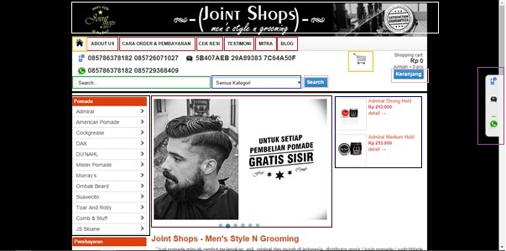

Widget Keranjang

Widget Dropdown

Widget Pencarian

Widget Menu Sidebar

Widget Slide

Widget Menu Item